**2025 H1 Société Générale Korea Trainee Recruitment**

SG Securities Korea Co., Ltd. and Société Générale Seoul Branch are Korea entities of the French global bank Société Générale Group. We are recruiting Trainees with following information and look forward on applications from students who wish to work at foreign Bank and Securities.

**[Introduction of SG]**

* Société Générale is a global bank with more than 117,000 employees in 66 countries worldwide.
* Korea Entities within Société Générale Group: 1) SG Securities Korea Co., Ltd. 2) Société Générale Seoul Branch

**[Recruitment Details]**

* CV submission : October 28th 2024(Mon.) ~ November 10th 2024(Sun.)
* Interview Date : Late November 2024 (Detailed schedule will be communicated to interviewees via email or call)
* Position Title : Trainee
* Employment Period : Around 6 months (1 year could be considered depending on company's circumstances)
* Hiring Departments : Below table to be referred
* Number of Openings : Tentative

**[Application Eligibility]**

1) Students who have more than 15 credits remaining at a 4-year university as of late December 2024

2) Students who can work full-time on mentioned Employment Period

3) Students with basic knowledge of MS-office, Business Administration, Economics and English proficiency

**[Documents to submit]**

* CV and Cover Letter in English
* File Format: **Please mention 1st and 2nd preferred departments of your choice on your resume.**

**(MARK, GLBA, RISQ, GTPS)**

**If not mentioned, department will be decided upon company’s discretion after reviewing the application.**

**If deemed more suitable on other departments than the ones you applied for, you may receive recruitment proposal on other departments.**

**Final sub-department will be confirmed through individual interviews after the first round of interview.**

* + Please indicate education background details (Primary, Middle, High school, University)
  + Those who have completed military service please indicate in the résumé
  + Indicate your nationality
* English Transcript issued during CV submission period
* Consent form for processing the personal information (for applicants)
* Queries related to recruitment : [seo-humn@sgcib.com](mailto:seo-humn@sgcib.com)
* **Application Link :** [**https://careers.societegenerale.com/en/job-offers/2025-h1-societe-generale-korea-trainee-24000PO6-en**](https://careers.societegenerale.com/en/job-offers/2025-h1-societe-generale-korea-trainee-24000PO6-en)

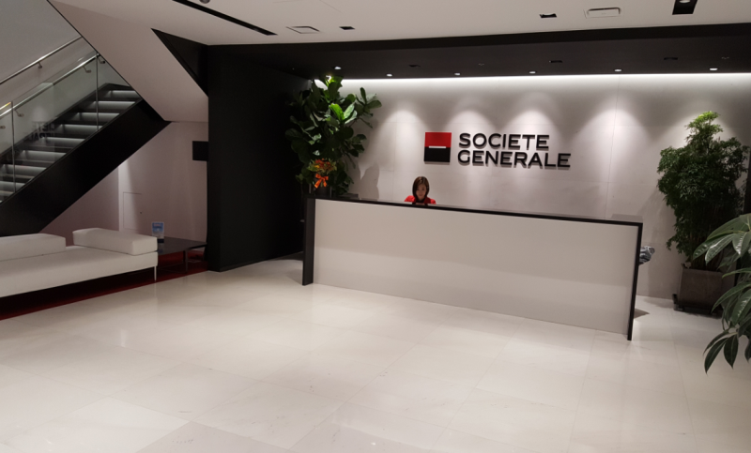

**[SG Securities Korea Co., Ltd. and Société Générale Seoul Branch Office Lobby]**

|  |  |  |  |
| --- | --- | --- | --- |
| **Entity** | **Departments** | **Sub-Department and Job Description** | **Employment Period** |
| **Securities**  **&**  **Bank** | Global  Markets  **(MARK)** | **Fixed Income & Currencies Sales (FIC Sales)**  - Working closely with Sales in charge of Corporate and Financial Institution by supporting daily transactions / pre-deal checks / marketing plans / pitching documents  - Composing daily FX and Rates market update as well as translating SG’s Internal report.  - Supporting material preparation as well as credit check covered by SG Sales team: FX & Rates Derivatives (including Credit, Options, Structured, Financing) | Late December 2024 ~  June 30, 2025 |
| **Fixed Income & Currencies Trading (FIC Trading)**  - Support main traders with timely updates by monitoring daily trades and cross-checking booking conditions to ensure accuracy and mitigate risks associated with trade discrepancies  - Author internal reports for the Seoul office including market flows, client order activities and EOD positions  - Monitor and check the risks involved in trade activities, leveraging understanding of the bank's risk profile and limits  - Learn how to price derivatives and enhance overall understanding of key trading strategies and approaches |
| **Equities & Derivatives Agency Sales (EQD Agency Sales)**  Responsible for sales and brokerage of equity and derivatives for major global/domestic financial institutions.  Sales trainee will be working closely with equity & derivatives sales by supporting daily post-trade checks / market search / pitch document preparation. |
| **Equities & Derivatives Trading (EQD Trading)**  Deal with listed stocks and equity derivative products including futures, total return swaps, etc.  - Report daily market updates including news and corporate events  - Generate regular reports to provide business snapshots support trading team  - Support trading team with pre-deal risk simulations and booking controls to ensure accuracy and to mitigate operational risks  - Work closely with trading teammates to understand structures of equity derivative products and trading strategies |
| Global Banking and Advisory  **(GLBA)** | **Coverage (COV)**  - Support the COV team being responsible in marketing and sales activities towards existing/new corporate & sovereign clients  - Assist the team for clients on banking solutions and related ad-hoc requests (market analyses, data collection etc.)  - Assist the team for ad-hoc requests from overseas client coverage teams and product teams globally  - Support the team for preparation of internal memos (e.g., pipeline reports, client/internal call memos, ESG reviews strategy/action plan memos) for reporting to the management of SG Korea and regional office  - Support the team for managing accounts in on-boarding process in compliance with KYC (Know Your Client) and FRA (Fraud Risk Assessment)  - Others being requested from the team | Late December 2024 ~  June 30, 2025  or  Late December 2025 |
| **Development and Structured Export Finance (DSE)**  Offering med- and long-term loan and financial advisory service associated with overseas development projects (CAPEX) financing across various industries in particular with the support from the two Korean Export Credit Agencies, KEXIM and K-SURE.  - Assist GLBA/DSE Korea team in origination, execution, and post-execution management of transactions i.e. gathering up-to-date market information, preparing client pitch materials, performing research for credit approval process, etc.  - Assist the ESG Champion of SG Seoul Branch for managing the ESG project pipeline, preparing ESG Newsletter, setting up the ESG strategy  - Assist GLBA/DSE Korea team for internal procedures i.e. various management and compliance reporting, etc.  - Support the team with administrative work when necessary |
| **Financial Institutions Group Coverage (FIG Coverage)**  Sales & marketing activities on financial institutions clients and development of new clients and management of business relationship with clients. Support on business activities with FIG clients in addition to annual review and follow-up on KYC, credit limit, risk management on FIG clients.  - Support and assist on FIG Bankers to stimulate sales with FIG clients(local & global financial market updates, paper work on marketing materials & various business management preparation)  - Assist on FIG business strategy & revenue/budget forecast and management  - Research and update on financial results of FIG clients and support to prepare annual credit review on FIG clients  - Support on KYC documents collection on FIG clients and assist other admin work in FIG team. |

|  |  |  |  |
| --- | --- | --- | --- |
| **Entity** | **Departments** | **Sub-Department and Job Description** | **Employment Period** |
| **Bank** | Risk  Management  **(RISQ)** | **RISK Management (RISQ)**  Responsible for identifying, measuring, monitoring, approving, and controlling risks pertaining to the branch’s activities. The team supervises Global Markets (MARK), Global Banking and Advisory (GLBA), and Global Transaction & Payment Services (GTPS) departments for risk management related tasks.  - To monitor market activities of trading desks for various financial products (Fixed Income, Forex, and its Derivatives)  - To monitor various risks (inclusive of credit & liquidity risks) of Project Finance, Trade Finance and other products  - To support production processes of daily risk reports related to SG Seoul Branch’s portfolio.  - To cover part of regulatory reports related to market-, credit-, and operational-risk management.  - To coordinate with regional risk teams which are located in Hong Kong. | Late December 2024 ~  June 30, 2025 |
| Global Transaction  & Payment Services  **(GTPS)** | **Trade Finance (GTPS)**  Provide various financial services to corporate clients related to the companies’ international trade activities or overseas projects by offering Letter of Credit/Guarantees, Receivables Discount, Import Loan products, etc.  - Assist sales/marketing activities for trade finance business (research company data, preparing client pitch materials, expense process, etc)  - Assist for transactional approval requests to Paris HO, corporate client’s credit process, and follow-up KYC (know your customer) process  - Support various internal reporting to Head Office/APAC/Local managements (statistics and data for regular/ad-hoc reports), and BOK report  - Assist Export Letter of Credit transactions  - Smooth communication with external clients and back-office in India.  - Support the team with administrative works when necessary | Late December 2024 ~  Late December 2025 |