**How Can We Best Collect Human-Oriented Molecular Biological Data?**

: Electrochemical Sensing for Everyone, Anywhere

The advent of AI and machine learning has unveiled a new dimension of personal healthcare information, enabling predictive and preventive approaches that are reshaping the future of healthcare. To harness these advancements and translate findings into practical applications, a convenient, economical, and effective means of extracting molecular biological data from human states is imperative.

This talk will review past, present, and emerging strategies for collecting molecular-level healthcare data, emphasizing the need for minimalistic, batteryless electrochemical sensors. Electrochemical sensors have established themselves as one of the most reliable methodologies for miniaturized biomedical devices, with their utility proven through the widespread adoption of continuous glucose monitors. However, traditional sensors rely on complex, expensive, and power-intensive peripheral readout circuits to maintain the controlled environments necessary for accurate electrochemical measurements.

Our work pioneers the development of wireless electrochemical sensors designed to function in minimally controlled environments, drastically reducing the need for peripheral electronics. This approach enables the scaling of sensors down to micrometer dimensions, eliminating the dependency on batteries. Such advancements open doors to integrating electrochemical sensors in unique and challenging environments, such as inside individual cells or in everyday items like diapers or paper towels.

To achieve this, we have undertaken material- and system-oriented efforts to amplify molecular biological signals (*1*–*4*). Additionally, we developed a phone-attachable, sticker-like reader to minimize the peripheral circuitry(*5*). One highlight includes a wireless amperometric sensor leveraging direct inductive coupling, demonstrating the feasibility of truly minimalist electrochemical sensing(*6*). We further introduce a diaper-incorporated, chipless, batteryless sensor tailored for large-scale population studies on Type 1 diabetes(*7*).

This work highlights the transformative potential of minimalistic sensors in revolutionizing healthcare by making it more accessible, affordable, and seamlessly integrated into daily life, laying a foundation for advancing human-oriented molecular biological data collection strategy.

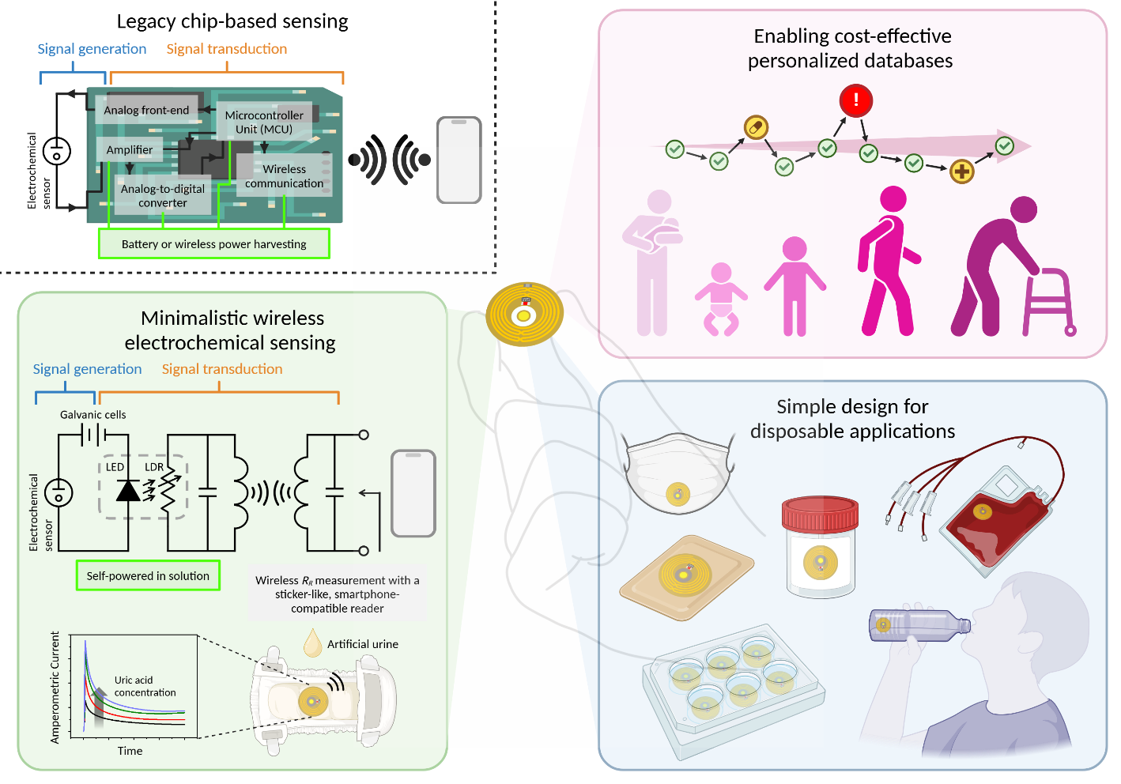

1. J. Rho, S. Y. Yeon, T. D. Chung, “Sensitivity-tunable and disposable ion-sensing platform based on reverse electrodialysis.” (2020)

2. J. Rho, S. Y. Lim, I. Hwang, J. Yun, T. D. Chung, Chemically Deposited Cobalt-Based Oxygen-Evolution Electrocatalysts on DOPA-Displaying Viruses. *ChemCatChem* **10**, 165–169 (2018).

3. J. Rho, W. Jang, I. Hwang, D. Lee, C. H. Lee, T. D. Chung, Multiplex immunoassays using virus-tethered gold microspheres by DC impedance-based flow cytometry. *Biosens Bioelectron* **102**, 121–128 (2018).

4. D. Lee, S. Lee, J. Rho, W. Jang, S. H. Han, T. D. Chung, 3D interdigitated electrode array in the microchannel free of reference and counter electrodes. *Biosens Bioelectron* **101**, 317–321 (2018).

5. S. Kananian, J. Rho, C. Chen, S. Mirjalili, A. Daus, M. gu Kim, S. Niu, E. Pop, H. S. P. Wong, Z. Bao, A. Mani, A. S. Y. Poon, A disposable reader-sensor solution for wireless temperature logging. *Device* **1** (2023). (co-first author)

6. J. Rho, A. Yang, J. Sands, H.-S. P. Wong, A. S. Y. Poon, Self-powered Wireless Amperometric Sensor with Direct Inductive Coupling for Disposable Point-of-care Diagnostics. *Science Advances (Under revision)* (2024).

7. J. Rho, A. Yang, H.-S. P. Wong, A. S. Y. Poon, Wireless Electrochemical Sensor Redefined: Self Powered and Minimalistic Glucose Sensor Integrated into Diaper for Early Diagnosis of Type 1 Diabetes . *In Preparation*.